

Business Template

Subject areas
Logo / Image

Contents
Business Description 3
1.1 the Benefits of implementing a database. Project Vision 3
2 Model description 3
2.1 Definitions & Acronyms 3
2.2 Logical Scheme 3
2.3 Objects 3

Business Description

the Benefits of implementing a database. Project Vision
Implementing a database for an e-commerce platform (marketplace) makes it possible to organize, store, and update information regarding customers, sellers, products, orders, payments, and delivery.
On a marketplace, various sellers can offer their products through a single platform. A customer can place an order containing multiple items, including products from different sellers. The «orders» table stores general information about an order, while the «order_items» table contains the individual products, their quantities, and their prices at the time of purchase. In the database, information regarding customers, sellers, products, addresses, payment methods, delivery methods, and statuses is distributed across separate tables. This reduces data duplication and simplifies the updating of records.
Relationships between tables are established using primary and foreign keys. Unique constraints help prevent the duplication of email addresses, status names, or order data.
The model also supports tracking the history of changes. The table «order_status_history» records status changes along with timestamps, allowing the system to retain information about previous states rather than just the current status.
The structure can be extended by adding new payment providers, delivery methods, merchants, products, or order statuses, without the need to overhaul the entire database.

Model description

Definitions & Acronyms

Customer — a person who purchases products through the marketplace.

Seller — a person or business that offers products for sale on the platform.

Product — an item offered for sale by a seller.

Category — a classification used to organize products.

Order — a purchase request created by a customer.

Order item — an individual product included in an order, together with its quantity and purchase price.

Payment — a financial transaction associated with an order.

Payment method — the method used to pay for an order, such as a bank card or bank transfer.

Delivery — the process of transporting an order to its destination.

Courier — a person responsible for delivering an order.

Delivery method — the selected delivery service or option.

Status — the current state of an order or delivery.

Order status history — a record of status changes for an order, including the time of each change.

Primary Key — a field or combination of fields that uniquely identifies a record.

Foreign Key — a field that references a primary key in another table.

One-to-Many) — one record in a parent table can be associated with multiple records in a child table.

Many-to-Many— multiple records in one table can be associated with multiple records in another table.

Objects
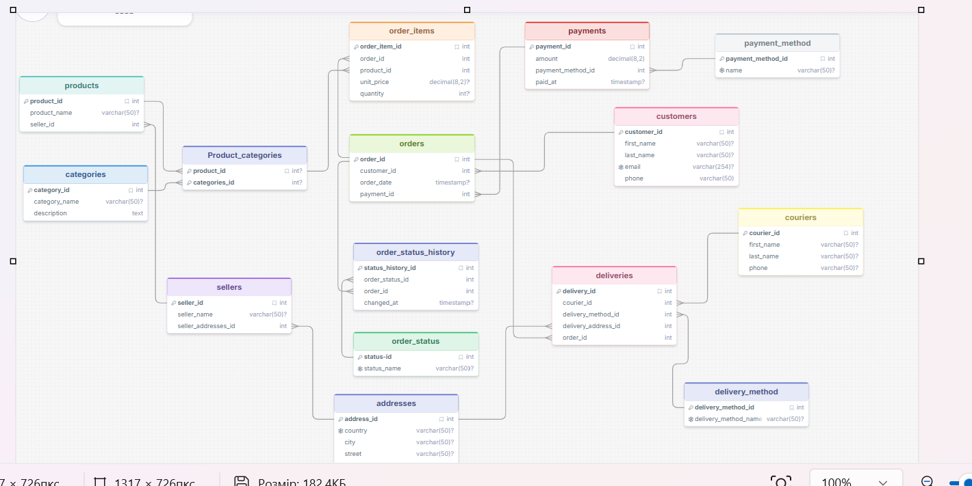

The logical scheme represents the main entities and processes of the E-commerce Marketplace. It consists of 15 tables: customers, sellers, addresses, categories, products, product_categories, orders, order_items, order_status, order_status_history, payments, payment_method, couriers, deliveries, and delivery_method.
One of the most important decisions was how to represent orders containing products from different sellers. The orders table represents the overall purchase, while order_items stores the individual products included in it. Each product is associated with its seller through products.seller_id. This avoids assigning an entire order to only one seller.
Separating sellers from products prevents seller contact details from being repeated for every product. Separating payment methods and delivery methods prevents the same method description from being stored repeatedly in transaction records.Primary keys prevent duplicate record identifiers. Foreign keys prevent orphan records, such as an order item referencing a product that does not exist. Unique constraints can prevent duplicate emails or tracking numbers. A separate order status history table preserves previous status changes.The model can support an increasing number of customers, sellers, products, orders, and deliveries. New payment and delivery methods can be added as records in their respective reference tables. New order statuses can also be introduced without adding new columns to the orders table.If the marketplace begins splitting orders between sellers into separate seller-specific shipments, the delivery structure may need to be extended. Refunds and partial payments may require additional transaction types or a dedicated refunds table. Product variants, discounts, inventory history, and customer reviews could also be added if the business requirements expand.
Table “Customers”.
Business purpose: Stores customer information used to identify people who purchase products through the marketplace..
Table Name |  |  | Field name |  | Field Description | Data Type
Customers |  |  | customer_id |  | PK, unique customer identifier | Int
 |  |  | first_name |  | Customer’s first name, not null | Varchar(50)
 |  |  | last_name |  | Customer’s last name, not null | Varchar(50)
 |  |  | email |  | Customer’s email address, not null | Varchar(254)
 |  |  | phone |  | Customer’s phone | Varchar(50)
A customer can be associated with multiple orders through order_id
customer_id | first_name | last_name | email | phone
1 | Kate | Richard | krichard@gmail.com | 038674563
2 | Tom | Kruk | kruk@gmail.com | 046729434
Table “Sellers”.
Business purpose: Stores information about sellers who offer products on the marketplace.
Table Name |  |  | Field name |  | Field Description | Data Type
Sellers |  |  | seller_id |  | PK, unique seller identifier | Int
 |  |  | seller_name |  | Seller name, not null | Varchar(50)
 |  |  | Seller_addresses_id |  | FK, reference to a seller address | Int
A seller can offer multiple products through seller_id. The address reference connects the seller to addresses.
seller_id | seller_name | Seller_addresses_id
1 | Hp market | 1
2 | Zoi Moon | 2
Table “Addresses”.
Business purpose: Address details used by the marketplace
Table Name |  |  | Field name |  | Field Description | Data Type
Addresses |  |  | address_id |  | PK, unique address identifier | Int
 |  |  | country |  | Country, not null | Varchar(50)
 |  |  | city |  | City or town, not null | Varchar(50)
 |  |  | street |  | Street name, not null | Varchar(50)
 |  |  | building |  | Building number, not null | Varchar(50)
 |  |  | apartment |  | Apartment number | Int
 |  |  | postal_code |  | Postal code | Varchar(50)
Address records are referenced by sellers and deliveries according to the foreign keys shown in the model
address_id | country | city | street | building | apartment | postal code
1 | Ukraine | Kyiv | Khreshchatyk | 28 | 2 | 01001
2 | Ukraine | Lviv | Zelena | 12 |  | 79008

Table “Categories”.
Business purpose: Stores product category information used to organize the product catalog.
Table Name |  |  | Field name |  | Field Description | Data Type
Categories |  |  | category_id |  | PK, unique category identifier | Int
 |  |  | category_name |  | Category name, not null | Varchar(50)
 |  |  | description |  | Category description | Text
Categories are connected to products through categories_id.
category_id | category_name | description
1 | Electronic | Electronic devices
2 | Home | Household products
Table “Products”.
Business purpose: Stores the product catalog and identifies the seller associated with each product.
Table Name |  |  | Field name |  | Field Description | Data Type
products |  |  | product_id |  | PK, unique product identifier | Int
 |  |  | product_name |  | Product name, not null | Varchar(50)
 |  |  | seller_id |  | FK, reference to the sellers | Int
A seller can have multiple products. Products are associated with categories through product_categories and can appear in multiple order items through order_items.
product_id | product_name | seller_id
10001 | Laptop | 1
10002 | Lamp | 2
Table “Product_categories”.
Business purpose: Connects product records with category records through their identifiers.
Table Name |  |  | Field name |  | Field Description | Data Type
Product_categories |  |  | product_id |  | PK, FK, product reference | Int
 |  |  | category_id |  | PK, FK, category reference | Int
The table represents the relationship between products and categories. Each field references the corresponding parent table. The two identifiers form a composite key in the model.
product_id | category_id
10001 | 1
10002 | 2
Table “Orders”.
Business purpose: Stores the product catalog and identifies the seller associated with each product.
Table Name |  |  | Field name |  | Field Description | Data Type
orders |  |  | order_id |  | PK, unique order identifier | Int
 |  |  | customer_id |  | FK, customer reference | Int
 |  |  | order_date |  | Date and time of the order | Timestamp
 |  |  | payment_id |  | FK, payment reference | Int
An order is associated with a customer and a payment. The order_items table stores the products included in an order. order_status_history stores the history of status changes associated with the order.
order_id | customer_id | order_date | payment_id
10001 | 1 | 2026-10-01 10:30:00 | 501
10002 | 2 | 2026-10-02 14:15:00 | 502
Table “Order_items”.
Business purpose: Stores individual products included in each order.
Table Name |  |  | Field name |  | Field Description | Data Type
Order_items |  |  | order_item_id |  | PK, unique order item identifier | Int
 |  |  | order_id |  | Fk, order reference | Int
 |  |  | product_id |  | Fk, product reference | Int
 |  |  | unit_price |  | Price per unit, not null | Decimal (8,2)
 |  |  | quantity |  | Number of units ordered, not null | Int
Each order item references one order and one product. An order can contain multiple order items, and a product can appear in multiple order items.
order_item_id | order_id | product_id | unit_price | quantity
1 | 10001 | 101 | 899,99 | 1
2 | 10002 | 102 | 25,50 | 2
Table “Order_status”.
Business purpose: Stores the possible statuses of an order..
Table Name |  |  | Field name |  | Field Description | Data Type
Order_status |  |  | status_id |  | PK, unique order status identifier | Int
 |  |  | status_name |  | Ststus name, not null | Varchar(50)
Status records are referenced by order_status_history.
status_id | status_name
1 | Pending
2 | Confirmed
3 | Shipped
Table “Order_status_history”.
Business purpose: Records changes to the status of an order over time.
Table Name |  |  | Field name |  | Field Description | Data Type
Order_status_history |  |  | order_status_history_id |  | PK, unique history record identifier | Int
 |  |  | order_status _id |  | FK, reference to the order status | Int
 |  |  | order_id |  | FK, reference to the order | Int
 |  |  | changed_at |  | Date and time of the status change, not null | Timestamp
Each history record references one order and one status. An order can have multiple status history records, and a status can be used in multiple history records.
order_status_history_id | order_status _id | order_id | changed_at
1 | 1 | 10001 | 2026-10-01 10:30:00
2 | 2 | 10001 | 2026-10-01 10:45:00
Table “Payments”.
Business purpose: Stores information about payments associated with marketplace orders.
Table Name |  |  | Field name |  | Field Description | Data Type
payments |  |  | payment_id |  | PK, unique payment identifier | Int
 |  |  | amount |  | Payment amount | Decimal(8,2)
 |  |  | Payment_method_id |  | FK, reference to the payment method | Int
 |  |  | paid_at |  | Date and time of the payment, not null | Timestamp
Each payment references a payment method. The orders table references payments through payment_id.
payment_id | amount | Payment_method_id | paid_at
501 | 899,99 | 1 | 2026-10-01 10:50:00
502 | 51 | 2 | 2026-10-01 10:55:00

Table “payment method”.
Business purpose: Stores the available payment methods.
Table Name |  |  | Field name |  | Field Description |  | Data Type
payment_method |  |  | payment_method_id |  |  | PK, unique payment method identifier | Int
 |  |  | payment_method_name |  |  | Payment method name, not null | Varchar(50)
One payment method can be referenced by multiple payment records.
payment_method_id | payment_method_name
1 | Bank Card
2
  Bank Transfer
Table “Couries”.
Business purpose: Stores information about couriers responsible for delivering orders.
Table Name |  |  | Field name |  | Field Description | Data Type
couries |  |  | courier_id |  | PK, unique courier identifier | Int
 |  |  | first_name |  |  | Varchar(50)
  Courier's first name, not null
 |  |  | last_name |  |  | Varchar(50)
  Courier's last name, not null
 |  |  | phone |  | courier's phone number, not null | Varchar(50)
A courier can be associated with multiple delivery records through courier_id.
courier_id | first_name | last_name | phone
1 | Stepan | Ilkiv | +380231111111
2 | Mykyta | Shpak | +380309816514

Table “Deliveries”.
Business purpose: Stores individual products included in each order.
Table Name |  |  | Field name |  | Field Description | Data Type
Deliveries |  |  | delivery_id |  | PK, unique delivery identifier | Int
 |  |  | courier_id |  | Fk, courier reference | Int
 |  |  | delivery_method_id |  | Fk, delivery method reference | Int
 |  |  | delivery_address_id |  | Fk, address reference | Int
 |  |  | order_id |  | Fk, order reference | Int
Each delivery references a courier, a delivery method, an address, and an order. These relationships connect delivery records to the people and entities involved in fulfilment.
delivery_id | courier_id | delivery_method_id | delivery_address_id | order_id
701 | 1 | 1 | 1 | 10001
702 | 2 | 2 | 2 | 10002

Table “delivery method”.
Business purpose: One delivery method can be referenced by multiple deliveries.
Table Name |  |  | Field name |  | Field Description |  | Data Type
delivery_method |  |  | delivery _method_id |  |  | PK, unique delivery method identifier | Int
 |  |  | delivery _method_name |  |  | delivery method name, not null | Varchar(50)
One payment method can be referenced by multiple payment records.
delivery _method_id | delivery _method_name
1 | Courier Delivery
2
  Delivery branch

